**Welcome to Day #7 of CGCC!**

Every day we will have a GitHub repository page that outlines each day and the activities that we will complete. We will also provide all homework on these pages.

Feel free to browse the other days to see what is coming up!

As always, let us know if you need any help or have any questions.

*Link to Camp GitHub*:<https://github.com/paigerodeghero/ClemsonGameCodingCamp/tree/master/2021>

**Day 4: Game Narrative Development**

**SCHEDULE:**

* Instructors start video call and recording
* Sharing Assets (with Group)
* Discuss Components of Video Games
* Brainstorm Final Project Game Idea (with Group)
* Break
* Character Sprite Import in GoDot
* Break
* Character Movement in GoDot
* *If time:* Group Game Development
* Instructors end video call

**ACTIVITY: Game Asset Sharing** (10 minutes)

One person from each team shares an asset or an asset idea that they’re working on.

Order of Teams:

* Group Aldebaran
* Group Deneb
* Group Rigel
* Group Vega
* Group Sirius

**INSTRUCTION**: Final Project Game Components (~45 min)

* **Character Discussion: (5 min)**
  + The Fighter: A hero who fights the enemy with their fists, feet, or weapon.
    - Examples: Street Fighter, Karateka, Mortal Kombat
  + The Big Bad: A dastardly villian who appears to be stronger than the hero, but has a hidden weakness.
    - Examples: Gannon, Donkey Kong
  + The Sage: A mystic, an odd character allied with the hero who provides helpful hints at crucial times during the game.
    - Examples: Legend of Zelda, Skyrim, Metal Gear Solid
  + The Sidekick: A companion to the hero who provides comic relief or aids the hero in solving their quest.
    - Examples: Luigi in Mario Bros, Yoshi in Mario World, Sonic 2's Tails.
* **Group Breakout Rooms (10 min)**
  + In the Team folder, open the Team Journal
    - As a group, answer the “Character Discussion” questions
* **Narrative Discussion (5 minutes)**
  + Overcoming the monster: The hero must fight and slay the monster that threatens their community.
    - Examples: Beowulf, Dracula, King Kong, Pacman, Mario Bros., Space Invaders, Asteroids, Galaga
  + Rags to Riches: An insignificant person is dismissed by others. Something happens to elevate them, revealing that person to be exceptional.
    - Examples: Ugly Duckling, Aladdin, Superman
  + The Quest: The hero must set out on a long hazardous journey to battle obstacles until they are triumphant.
    - Examples: Lord of the Rings, Harry Potter, Wizard of Oz
  + Voyage and Return: The hero travels out of their normal world into the unknown and overwhelming, before escaping back to the safety of their home.
    - Examples: Alice in Wonderland, Finding Nemo, Gulliver's Travels, Legend of Zelda, Super Mario Bros.
  + Rebirth: The hero falls under a dark spell (e.g. sleep, sickness, enchantment) before breaking free and being redeemed.
    - Examples: Sleeping Beauty, Beauty and the Beast
  + The Neverending Story: A repetitive story with infinite challenges that get more and more difficult to beat
    - Examples: Donkey Kong, Q*bert, Tetris
* **Group Breakout Rooms (10 min)**
  + In the Team folder, open the Team Journal
    - As a group, answer the “Narrative Discussion” questions
* **Rules Discussion (5 minutes)**
  + Navigation
    - Walking, Running, Swimming, Flying
    - Constraints to only walk up/down, left/right
  + Information
    - Reading a scroll
    - Listening to a character
  + Inventory
    - Picking up an item
    - Choosing to use an item
    - Dropping an item
    - Losing an item
  + Obstacles
    - Jumping
    - Running through
    - Punching at
  + Fighting
    - Punching at
    - Jumping on top of
    - Kicking
    - Running through
    - Round-off backhandspring
  + Dying
    - Getting run over
    - Getting hit
    - Jumping into a pit
    - Running into yourself
  + Winning
    - Eating all of the food
    - Defeating all the enemies
    - Solving all the puzzles
* **Group Breakout Rooms (10 min)**
  + In the Team folder, open the Team Journal
    - As a group, answer the “Rules Discussion” questions

**10 Minute Break**

**ACTIVITY:** GoDot Development: Importing Sprites (30 min) (Individual)

1. Create a character on <https://www.piskelapp.com/>
2. Export selected frame as a PNG.

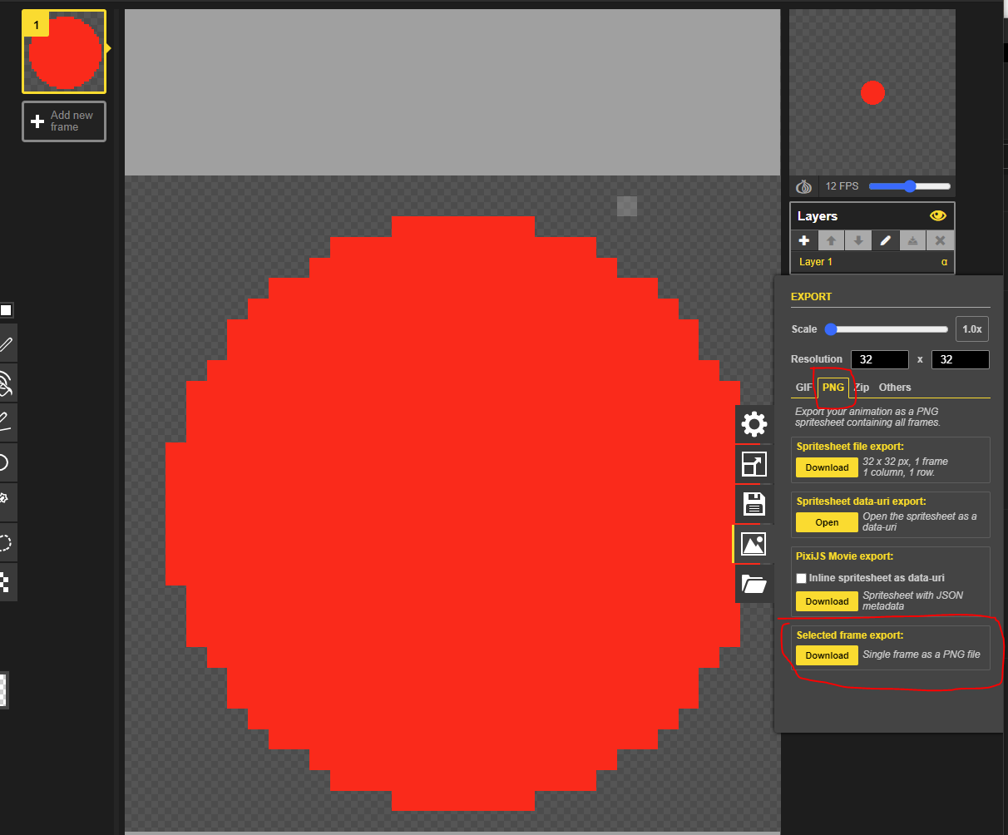

1. Next open GoDot and create a New Project 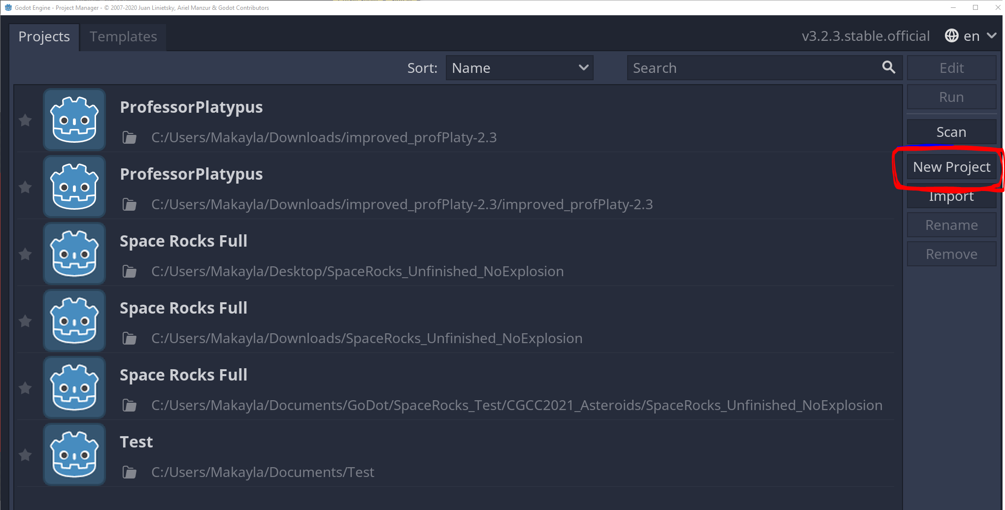
2. Name the Project: Day7Example . We will have to create a new folder to save our project to, so click “Browse” -> “Create Folder” -> Name the Folder (I chose Day7) -> “Select This Folder” -> “Create & Edit”.

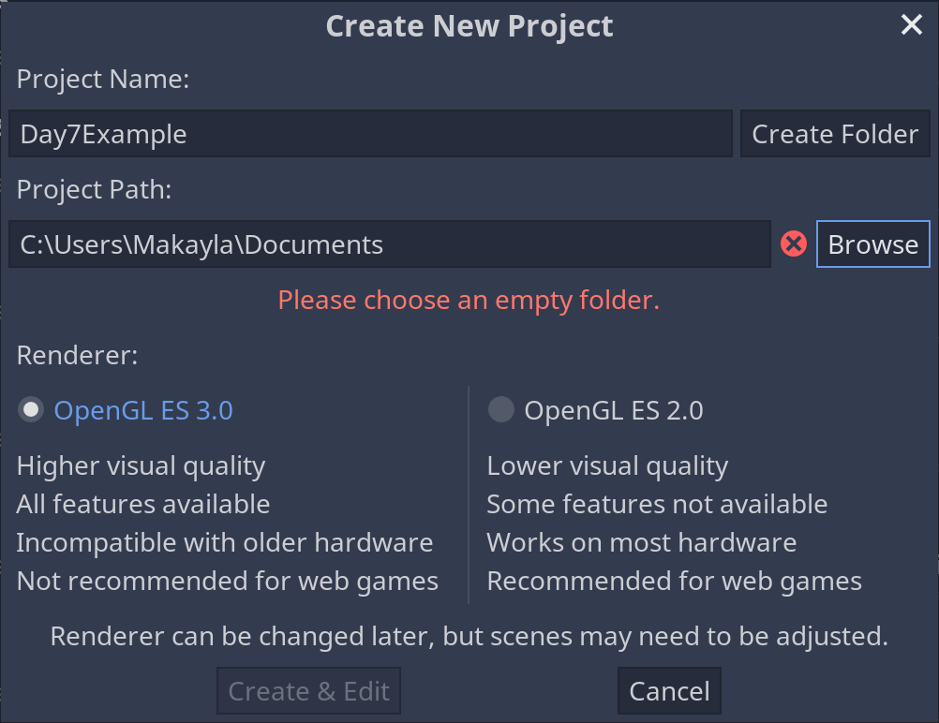

1. Now we have an empty project. We want to change the view from 3D to 2D at the top of our project window.

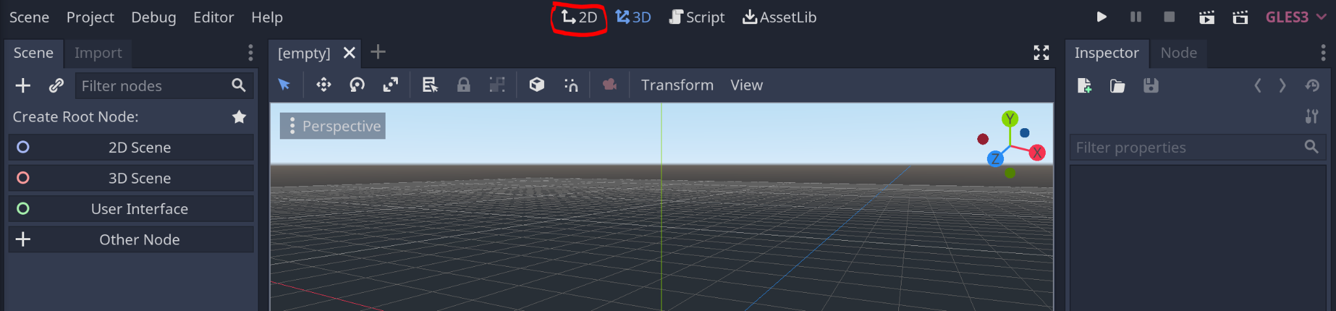

1. Add a Node to the scene and save it as Main.tscn.

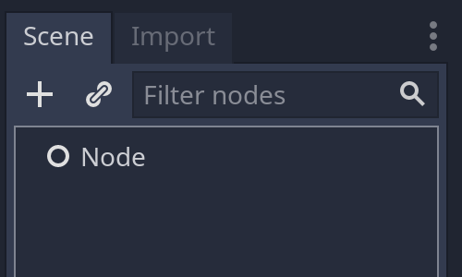

1. Next we need to add another Scene for our Player. Press the plus button next to the Main scene to add a new scene to our project.

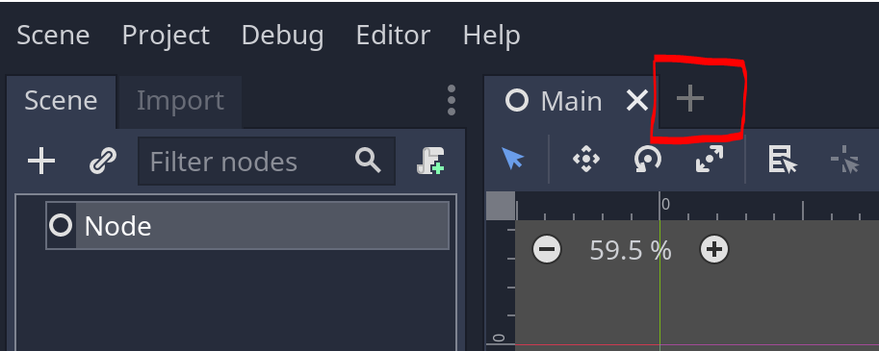

1. Next we are going to add a KinematicBody2D node to our scene and rename it to Player. Click the plus under Scene and search for KinematicBody2D.

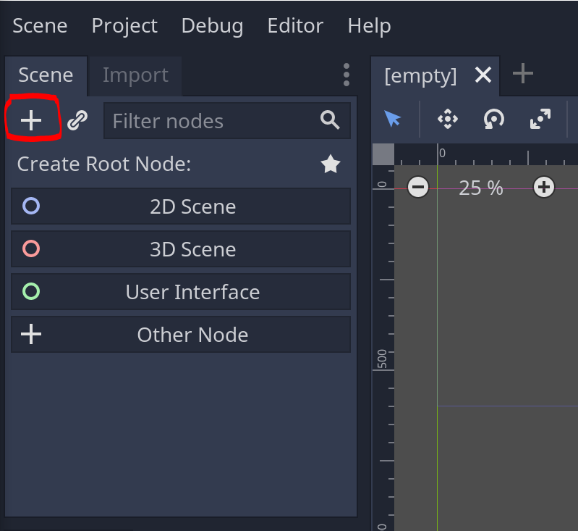

1. Next, we need to add a Sprite node and a CollisionShape2D node as children nodes to our Player node. (right click Player -> Add Child Node). Your scene should look like this:

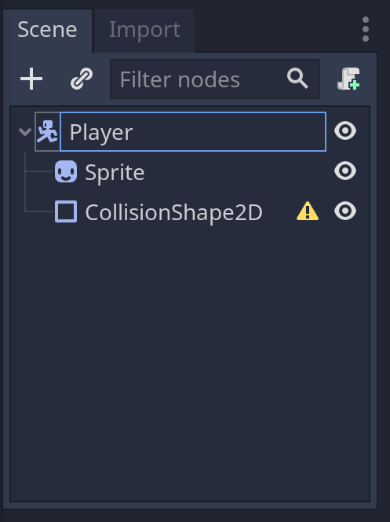

1. So now we need to move the character PNG we downloaded from Piskell to our Project Folder.
   1. Our PNG is in our Downloads Folder, find it and copy the file.
   2. Navigate to your project folder, create a new folder called Assets
   3. Paste your PNG into your Assets folder.
2. Click on the Sprite node in the Scene tab. In the Inspector, find Texture and click the dropdown arrow. Click load.

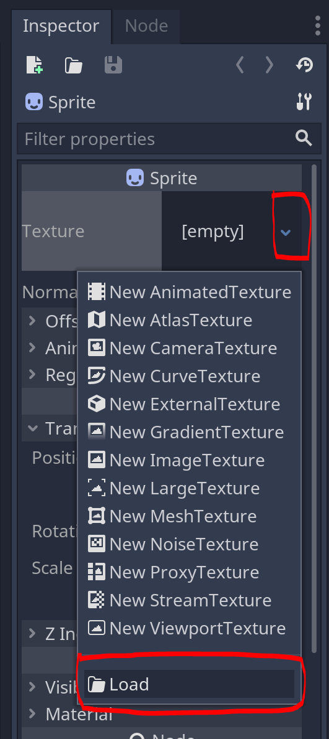

1. Find the PNG we just added to the Assets folder and double click to add to our scene. Feel free to change its size with the handles or the scale within the Transform tab in the Inspector.
2. Now we need to add a shape to our CollisionShape2D. Click on the CollisionShape2D node in the Scene tab.
   1. In the Inspector tab, find the Shape dropdown. Choose the New CircleShape2D option.

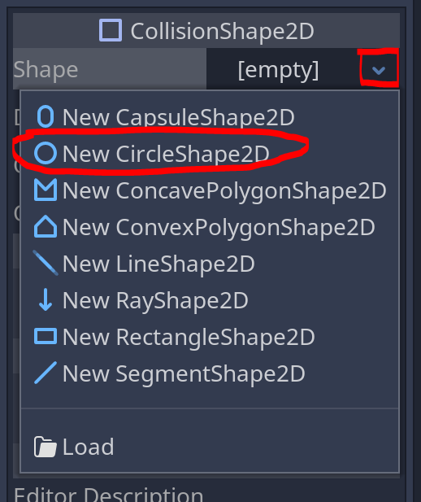

* 1. Resize to fit the size of your character PNG.

1. Save your scene as Player.tscn

**Breakout Rooms (10 minutes)**

Now we are going to open Breakout rooms for 10 minutes to ensure everyone is caught up.

**ACTIVITY:** GoDot Development: Sprite Movement (Individual) (45 min)

1. Now to add the movement to our character. First we need to add the keys that will move the character to our project.
   1. Open the Project -> Project Settings -> Input Map

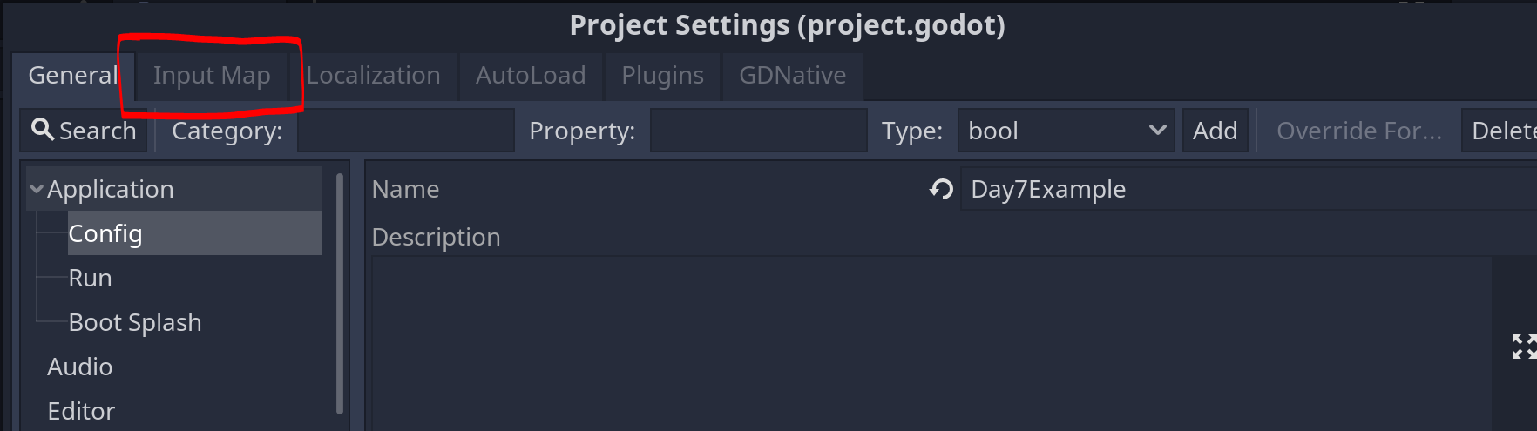

* 1. Once we have the Input Map tab open, we can add actions using the Action bar.

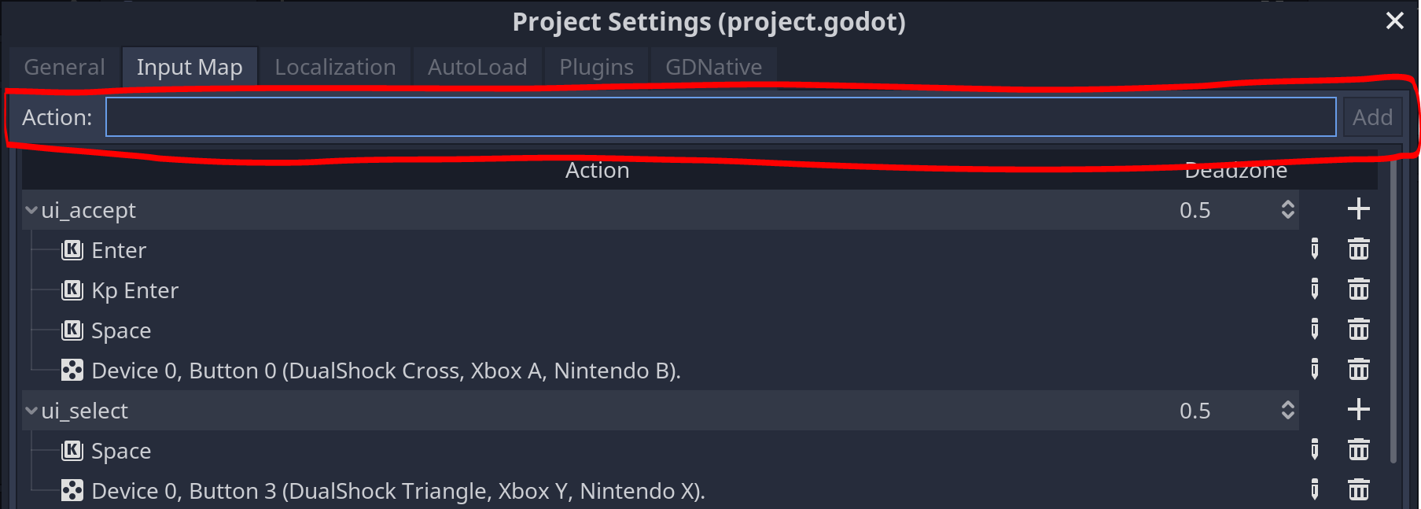

* 1. Lets add left, right, up, and down as actions.

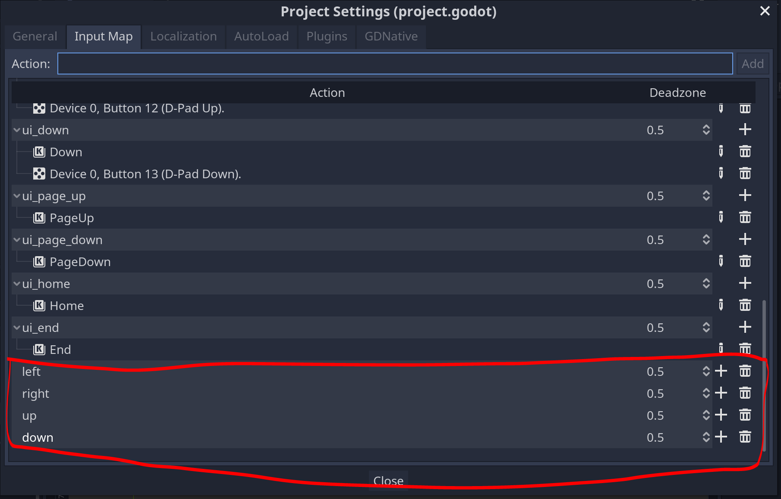

* 1. Now we can click the plus button next to each action and add the corresponding key (or multiple keys). Since we’re using a keyboard, we want to choose “Key.”

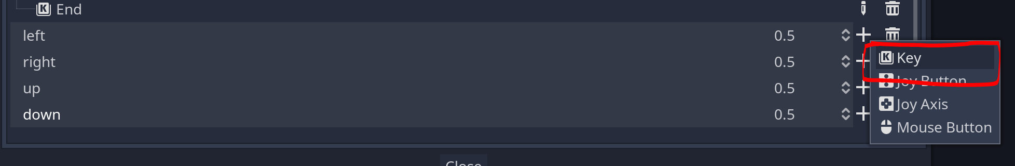

* 1. After pressing the “Key” button, choose the key that you want to use for that action. I chose to use WASD and the arrow keys as shown below:

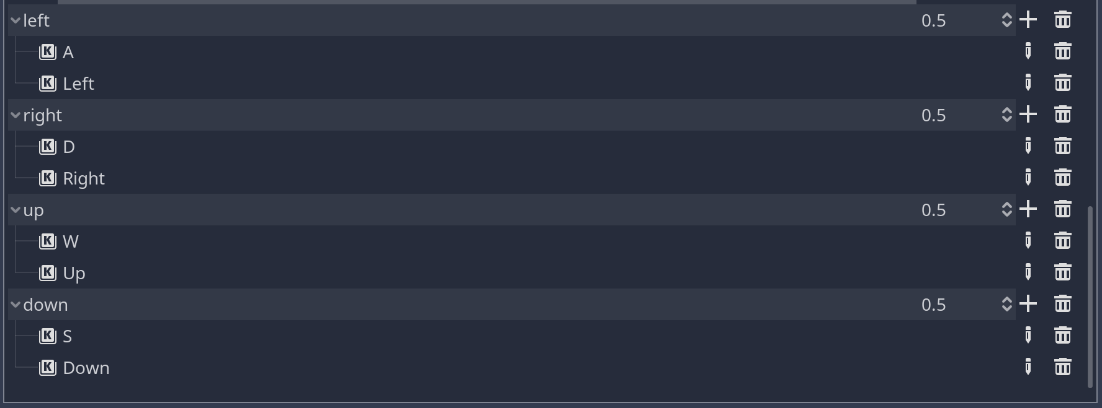

Breakout room break?

1. Now we need to add an instance of our Player scene to our Main scene. Go back to the Main tab, right click on Node, click Instance Child Scene and choose our Player.tcsn

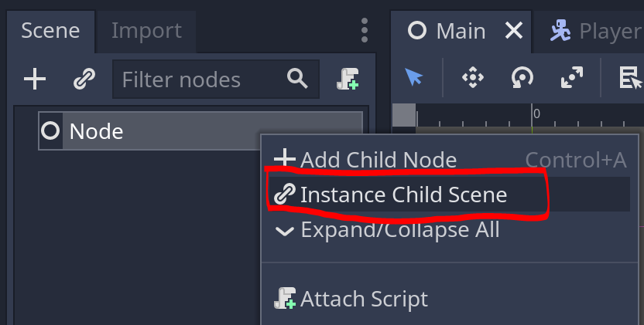

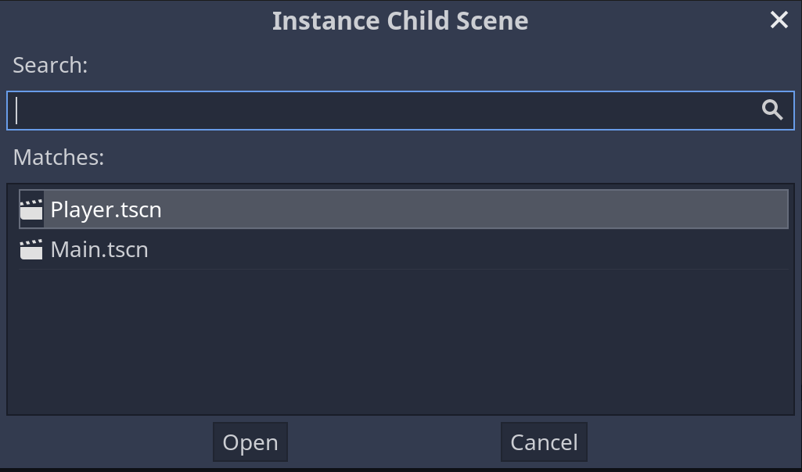

1. So now that we have our main scene, let's see if we can move our Player. Press the play button in the top right.

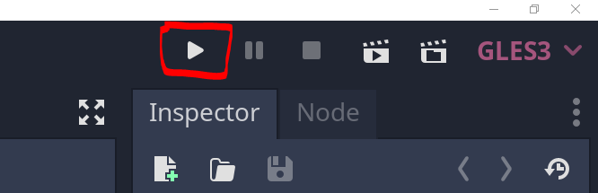

* 1. A popup will show on the screen, click “Select” and choose Main.tcsn.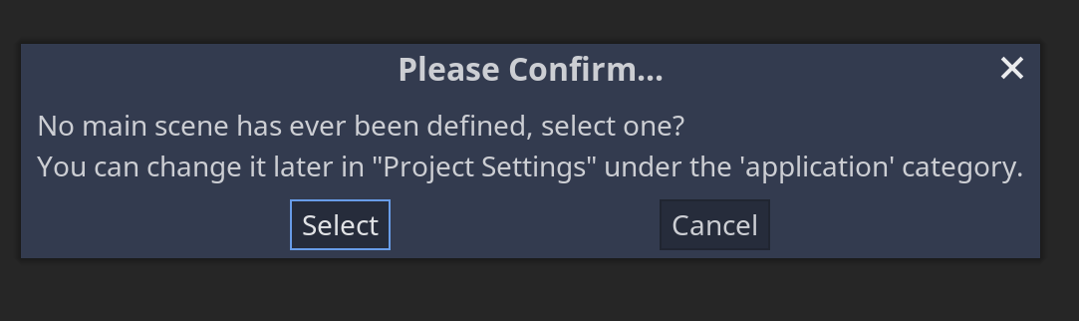

* 1. Hit Play once more. Can we move our character around? We can’t, so now we need to add a script to our Player node.

1. Head back to the Player scene and click on the Player node. Click on the scroll to add a new script and click Create.

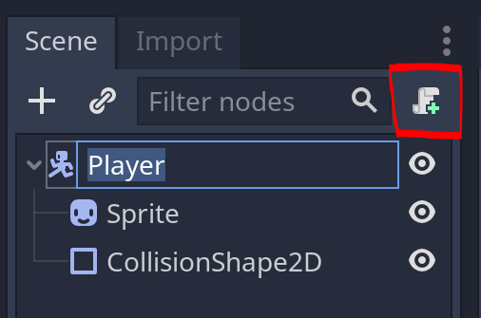

1. Save your scenes and open VS Code. We don’t have the correct folder imported into our VS Code, so now we need to add it.
   1. Right-click the current folder and click “Remove Folder from Workspace”
   2. Click File -> Add Folder to Workspace
   3. Navigate to the Day7 folder and click “Add”
   4. Open Player.gd
2. Now we can add code to our Player script.
   1. Let’s start with the get_input() function

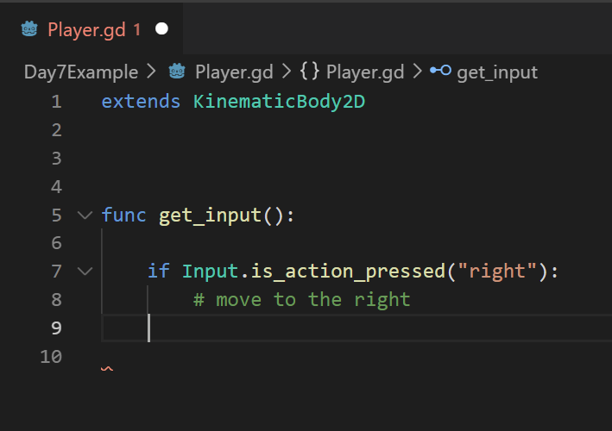

* 1. But how do we move to the right? We need to know what direction the character is moving, so we need to know their velocity. Let’s make a velocity variable on line 3.

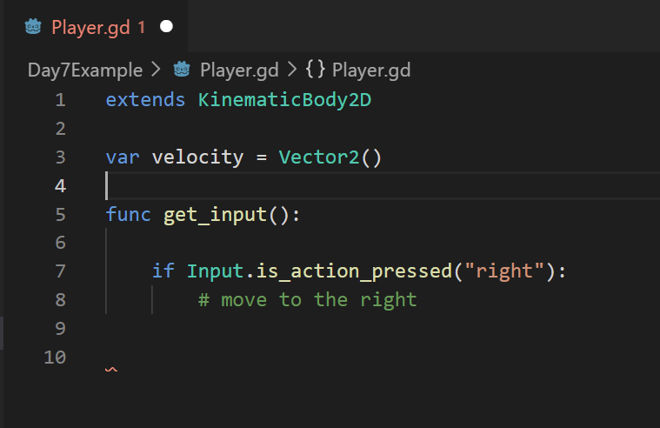

* 1. But what is a Vector2? A vector2 holds a point in the XY coordinate space, a number in the x coordinate axis and a number in the y coordinate space, that tells which direction the character should move in.
     1. So if we want to move left or right, we need to update the number that corresponds to x in our vector.
     2. And if we want to move up and down, we need to update the number that corresponds to y in our vector.

1. So now that we know what a vector is, we can add the below code (lines 6 - 14) to our Player.gd file

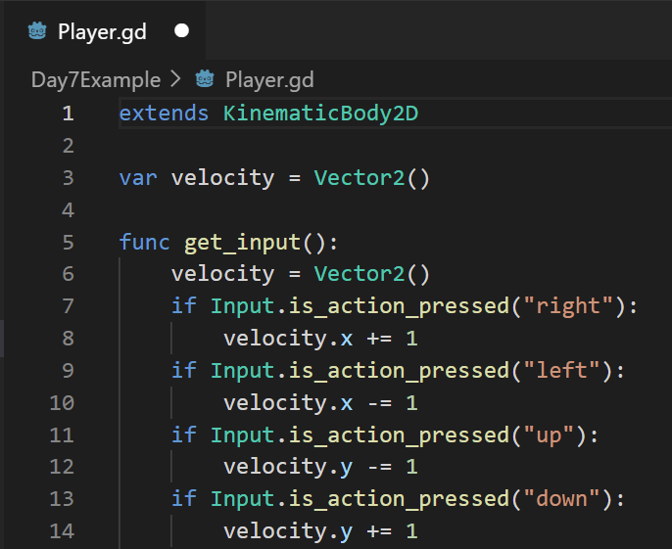

Breakout room break?

1. To move our character, since it’s a KinematicBody2D, we’ll need to use a function called _physics_process(delta). This function has physics already built in so we don’t have to worry about it. Add lines 16 - 18 to your script.

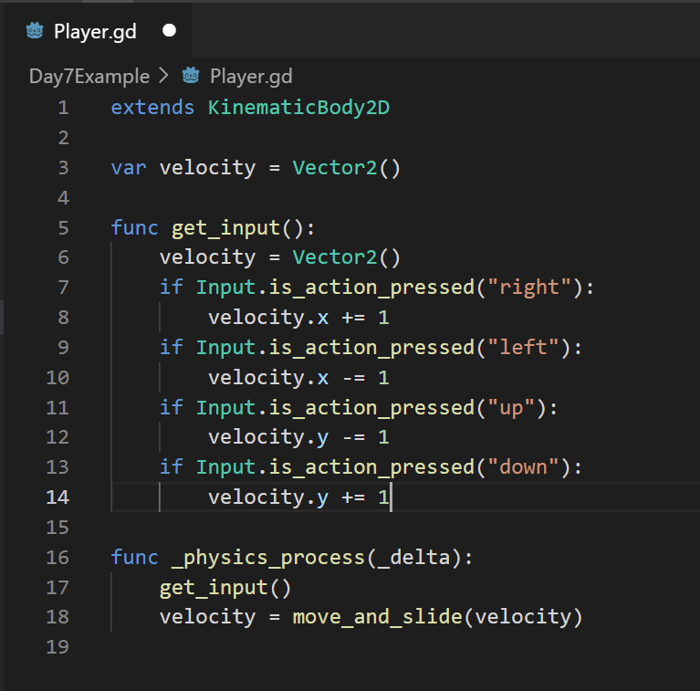

1. Now save your script, go back to GoDot, and play your game. You should see that your character **moves VERY slowly** since we’re only moving one pixel at a time. We can add a variable for speed and multiply our velocity by it to make the character move quicker. Add line 4 and 16 to your script.

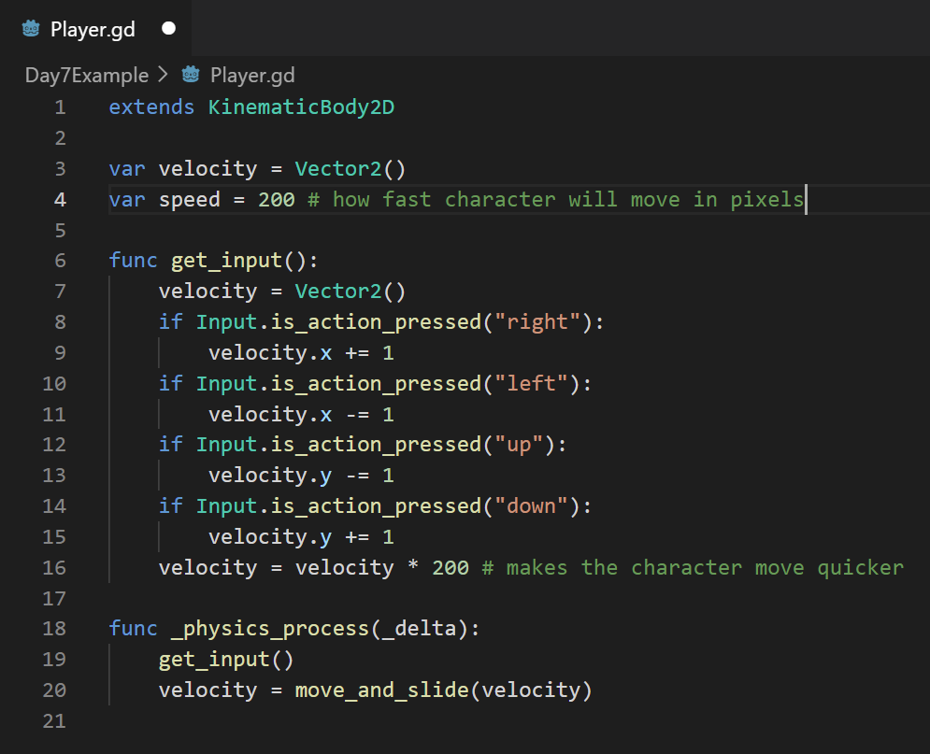

1. Lastly, if we hold the up and right keys, we will notice that the character moves faster in the diagonal direction than in the forward direction. We need to modify line 16 as follows:

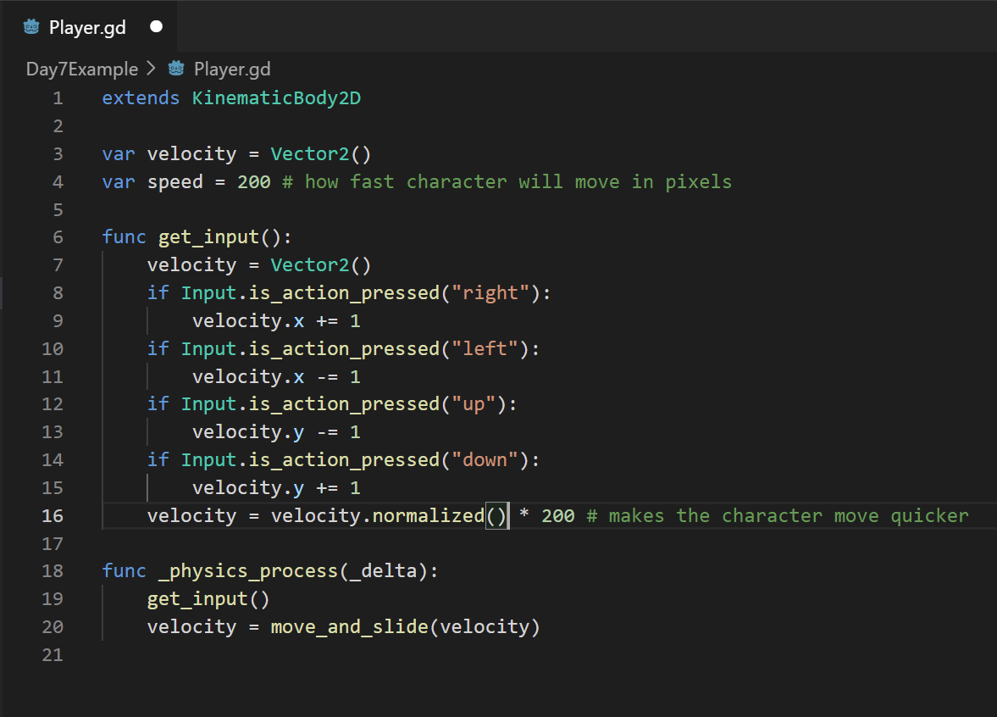

* 1. Which will make the character move the same speed in all directions.

**ACTIVITY: Game Development**

In your groups, continue working on game brainstorming, asset design, and character movement.